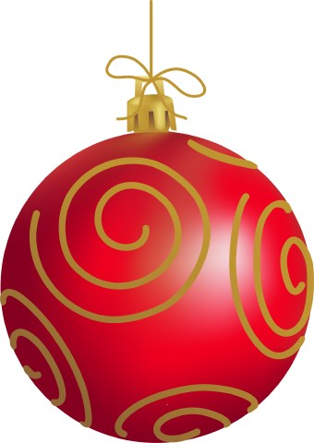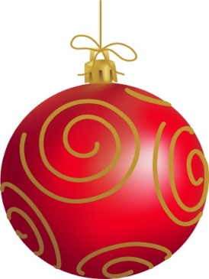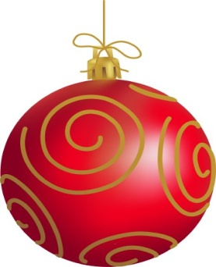

**Sun City Civic Association**

**5PM**

**DINNER IN NORTH TOWN HALL**

Christmas With The Core Saturday December 17TH, 2016 26850 Sun City Blvd. Sun City Ca. Christmas Ball Commences at 5pm

**TICKETS $16**

**EACH**

**LIVE MUSIC IN WEBB HALL LIVE by: GUITARS AND MELODIES**