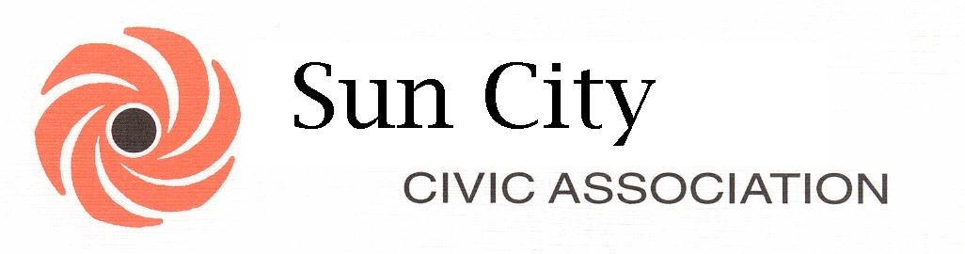
26850 SUN CITY BLVD. SUN CITY, CALIFORNIA 92586-2948 PHONE (951) 679-2311 FAX (951) 672-9542

NOTICE OF SCCA MEETINGS
IN: DECEMBER 2014

This serves as due notice of the following meetings, where all or part of the Board are expected to be in attendance, and are currently scheduled to be held on:

Wed, December 3rd – Executive Board Meeting (ER) – 9:30am

Fri, December 5th – Coordinating Council General Meeting (NTH) – 9:00am

Tues, December 9th – SCCA Emergency Preparedness Committee (CANCELLED)

Wed, December 10th – SCCA Social Activities Committee Meeting (ER) – 9:00am

Wed, December 17th – SCCA Finance Committee Meeting (CANCELLED)

Thurs, December 18th –SCCA BOD Violation Hearings (CANCELLED)

Fri, December 19th – Ways and Means Committee Meeting (WR) – 10:00am

Thurs, December 25th – SCCA BOD Executive Session (CANCELLED)

Thurs, December 25th – SCCA Monthly BOD Meeting (CANCELLED)

NOTE: Half Day 12/24 and 12/31 & we’re closed 12/25 and 1/1!!!!!!

Thank you. Please come into the office if you have any questions concerning these meetings.
Revised: 5/16/14

